2200030216 TASK-6 Exercise 1: Mocking and Stubbing

Steps: 1. Create a mock object for the external API. 2. Stub the methods to return predefined values. 3. Write a test case that uses the mock object.

Myservicetest.java

package com.example;

import org.junit.jupiter.api.*Test*;

import static org.junit.jupiter.api.Assertions.assertEquals;

import static org.mockito.Mockito.\*;

class MyServiceTest {

    @*Test*

*void* testExternalApi() {

        // 1. Create mock

        ExternalApi mockApi = mock(ExternalApi.class);

        // 2. Stub behaviour

        when(mockApi.getData()).thenReturn("Mock Data");

        // 3. Use mock in service

        MyService service = new MyService(mockApi);

        String result = service.fetchData();

        // 4. Assert + optional verify

        assertEquals("Mock Data", result);

        verify(mockApi).getData(); // proves the call happened

    }

}

Externalapi.java  
package com.example;

public interface ExternalApi {

    String getData();

}

Myservice.java  
package com.example;

public class MyService {

    private final *ExternalApi* api;

    public MyService(*ExternalApi* *api*) {

        this.api = api;

    }

    public *String* fetchData() {

        // could contain more logic, caching, etc.

        return api.getData();

    }

}

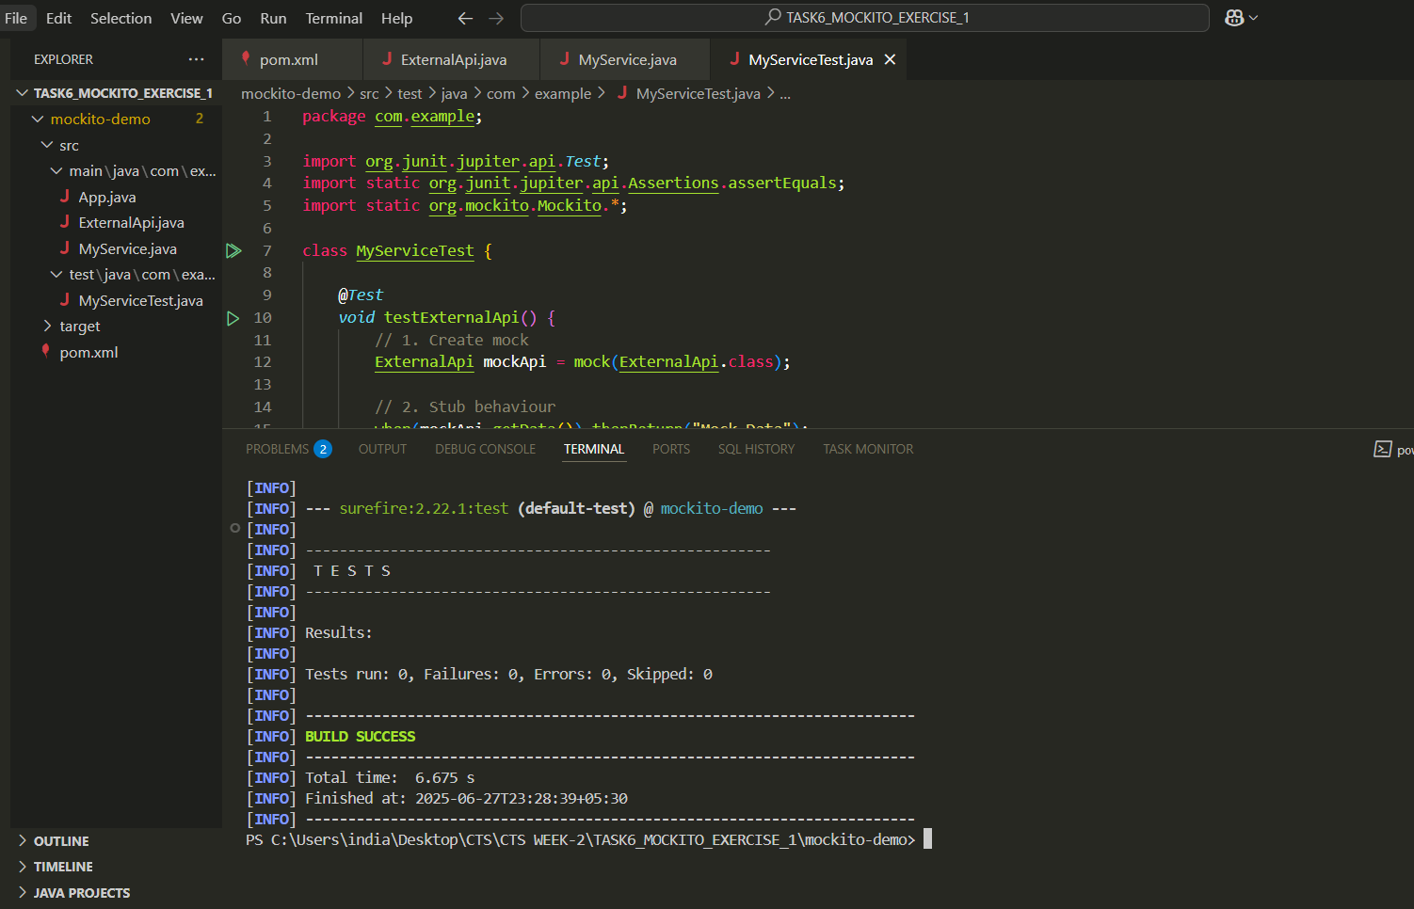  
we can see the test run  
  
file format  
